Contents

160540A / Lai Wei Jing, Eugene 3

Enemy Artificial Intelligence 3

Turret [Enemy] 3

Robot [Enemy] 6

Map Editor 7

Debugger 7

Text Manager 8

Conversation Message 8

Battle Message 9

Impact Message 10

BGM and SFX 11

Battlefield 11

Gun shot 11

Text display 11

163940Z / Chan Zhihao 12

Camera 12

Pan to target and pause. 12

Pan to multiple location 13

Particles 14

Rain 14

Melee 15

Stab and Slash Combo 15

Menu 16

Main Menu 16

Level Selection 17

Enlarged mini-map 18

161725E / Lim Guan Sheng, Marcus 19

File Manager 19

Write Level 19

Write Enemy 19

Load Level 20

Load Enemy 21

Inventory 22

Equipment 23

Shop 25

Purchase equipment 25

160853T / Kwong Yu Ming 26

Attributes 26

Gamepad 26

Quest Manager 27

Transformation of Objects 27

Walking animation [Robot] 27

Object and TGA 28

# 160540A / Lai Wei Jing, Eugene

## Enemy Artificial Intelligence

### Turret [Enemy]

Health bar shrinks accordingly to health left.

Scale capped at a fixed amount.

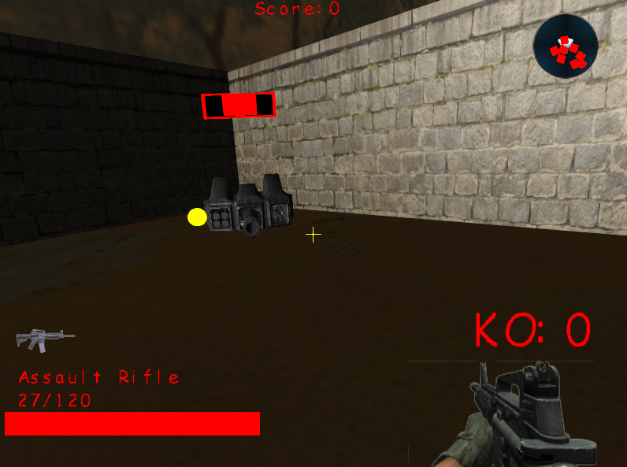

The red outer quad represents the status of the turret. [Ally or Enemy]

When the turret’s status is Enemy, it will be red colour.

The turret will target player and player’s turret.

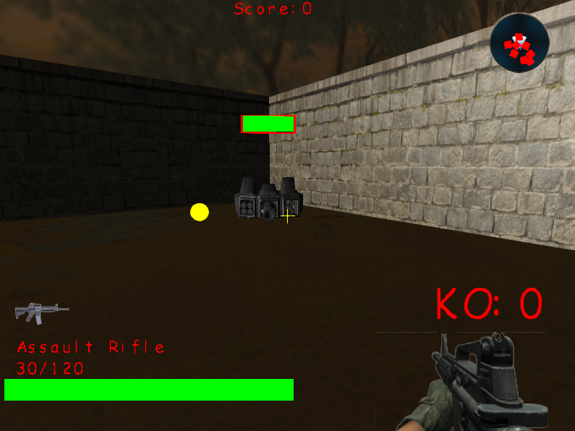

Ally Mode.

The turret targets all enemies.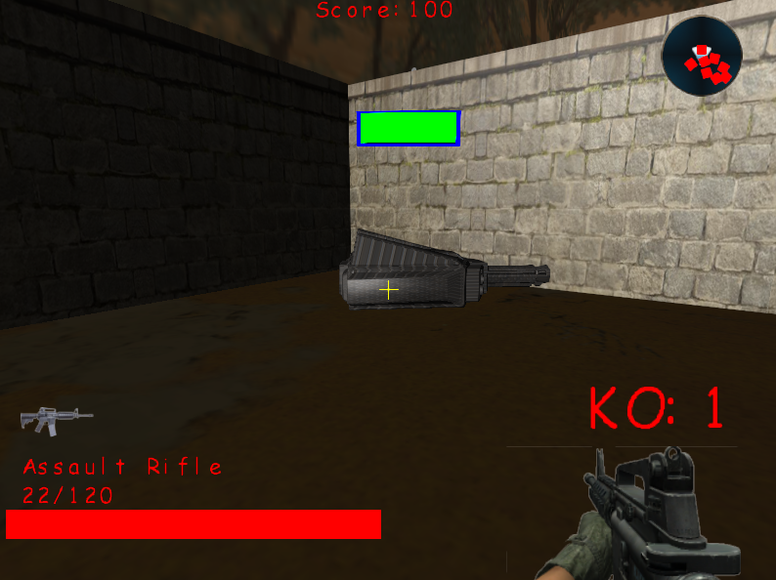

### Robot [Enemy]

Pathfinding logic that prevents the robot from colliding with one another.

Creates a create of nodes around the enemy, if it collides with any other object(s), erase the node. Check the remaining nodes for the shortest distance and move enemy towards that point.

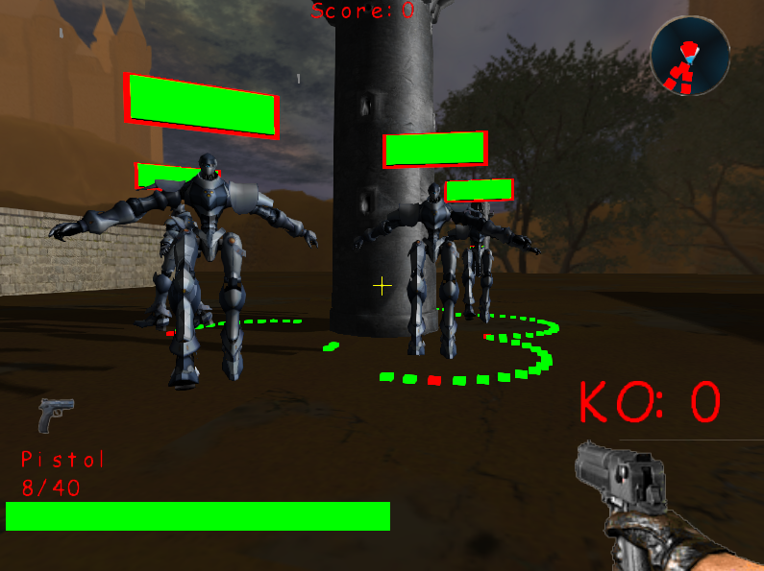

## Map Editor

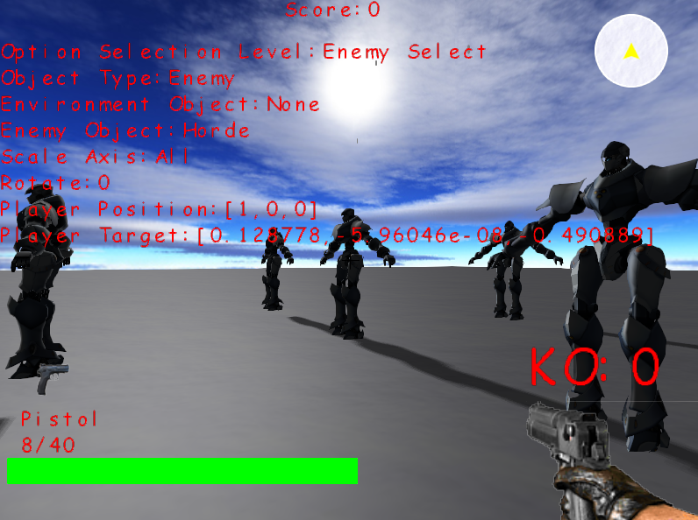

## Debugger

Used to cout messages that we defined only when the Debugger is turned on.

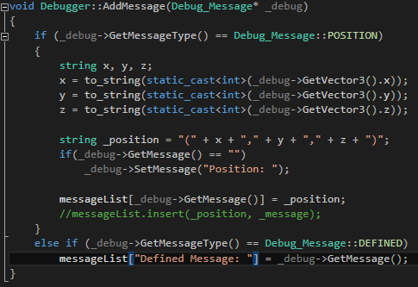

## Text Manager

### Conversation Message

Print the characters one by one.

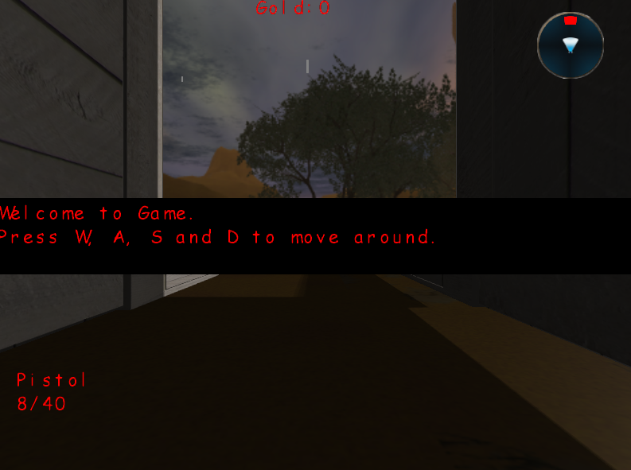

### Battle Message

Displaying level objective and remaining towers.

Message will slowly expand to the entire width of the screen.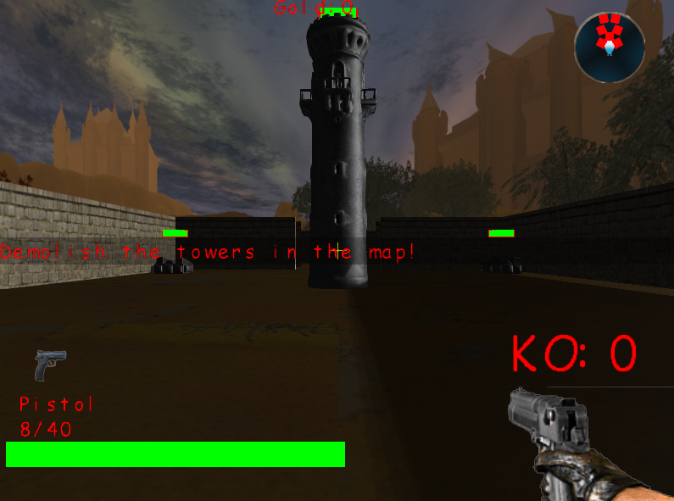

### Impact Message

Printing each key one by one on screen when special enemy appeared.

Character will reduce scale size and increase when it is added to the screen.

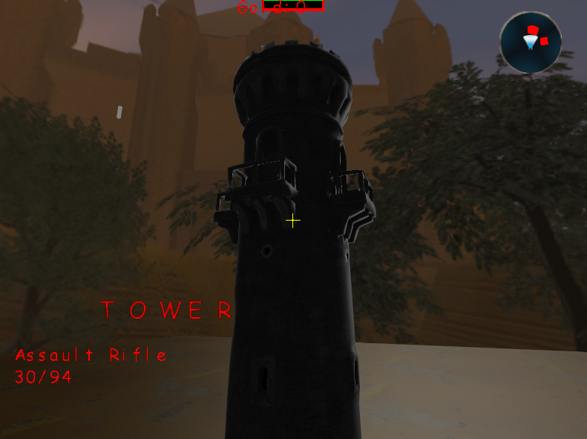

## BGM and SFX

### Battlefield

### Gun shot

### Text display

# 163940Z / Chan Zhihao

## Camera

### Pan to target and pause.

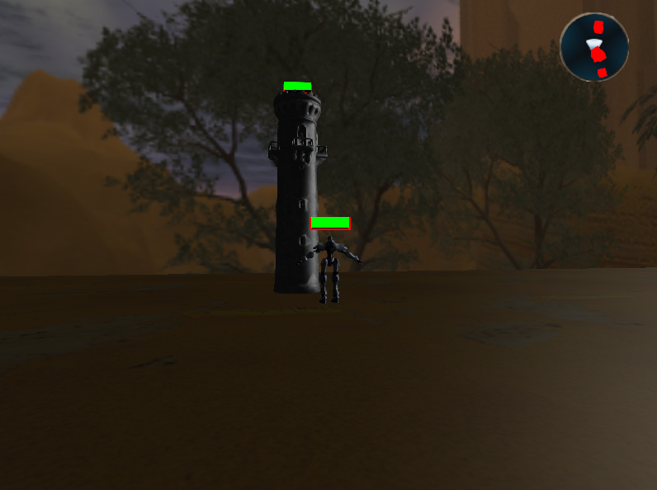

### Pan to multiple location

Move camera from one location to another and continues.

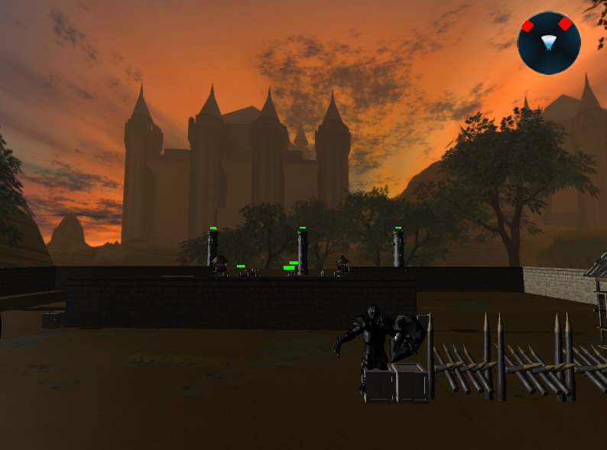

## Particles

### Rain

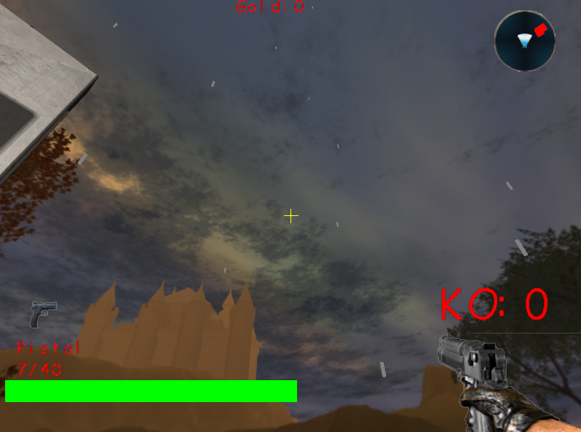

## Melee

### Stab and Slash Combo

Right clicking 4 times in a row will produce a slash on the 5th click.  
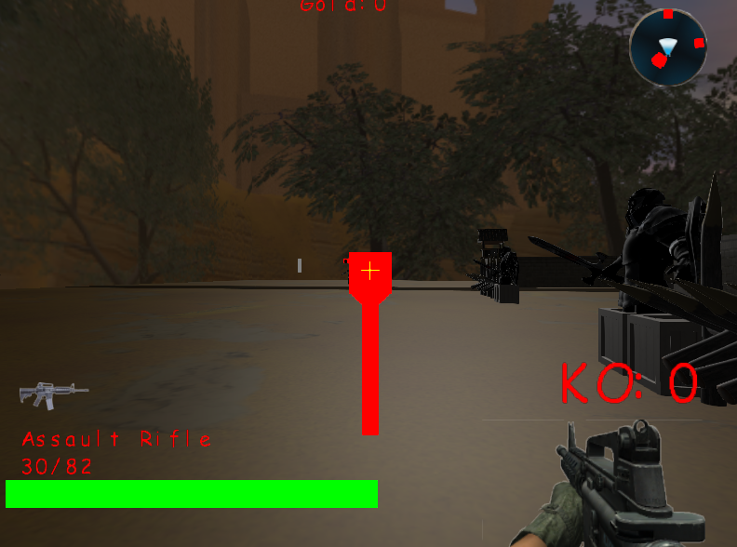

## Menu

### Main Menu

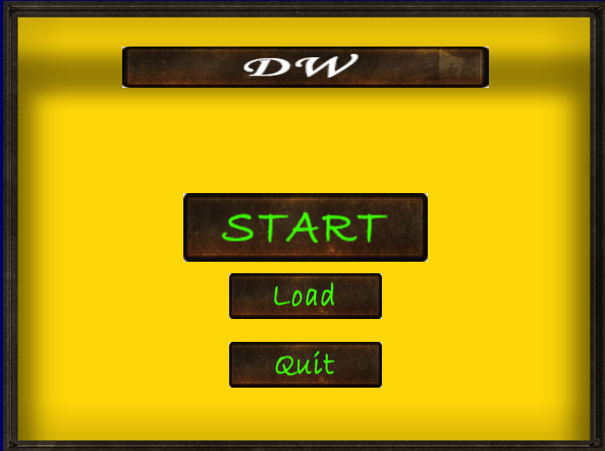

### Level Selection

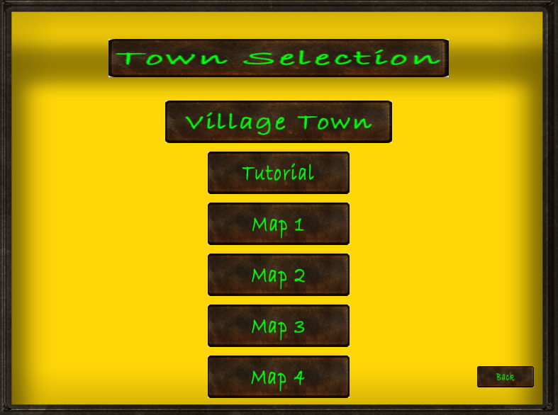

## Enlarged mini-map

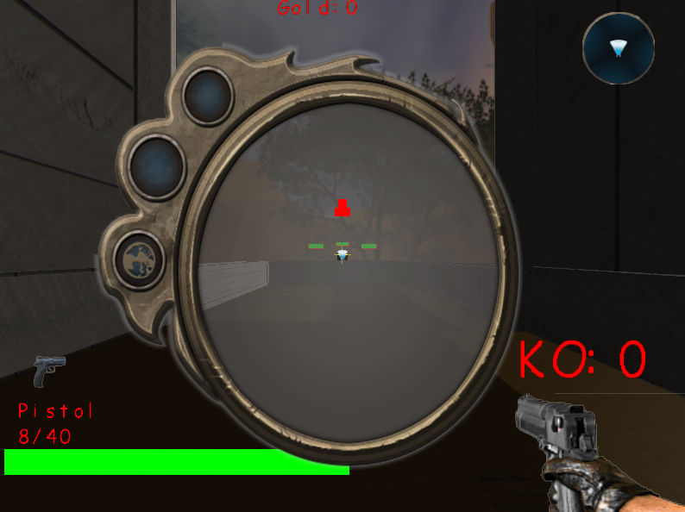

# 161725E / Lim Guan Sheng, Marcus

## File Manager

### Write Level

Writing the objects created using Map Editor to a CSV file.

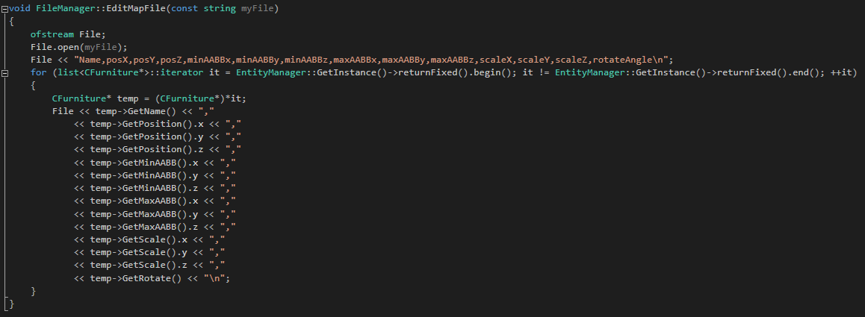

### Write Enemy

Writing the enemies created using Map Editor to a CSV file.

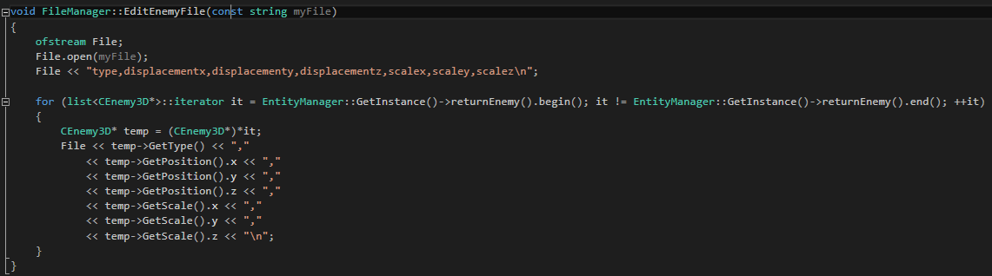

### Load Level

Loading objects from CSV to level.

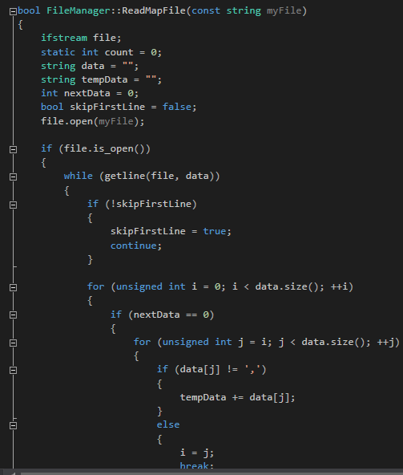

### Load Enemy

Loading enemies from CSV to level.

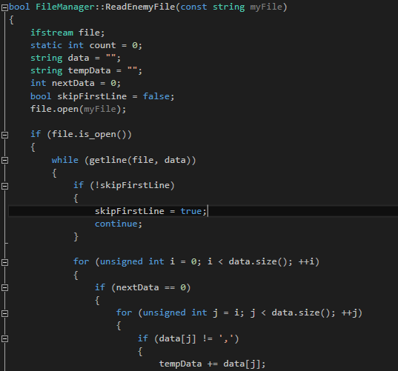

## Inventory

Storing equipment for equipping, unequipping and discarding.

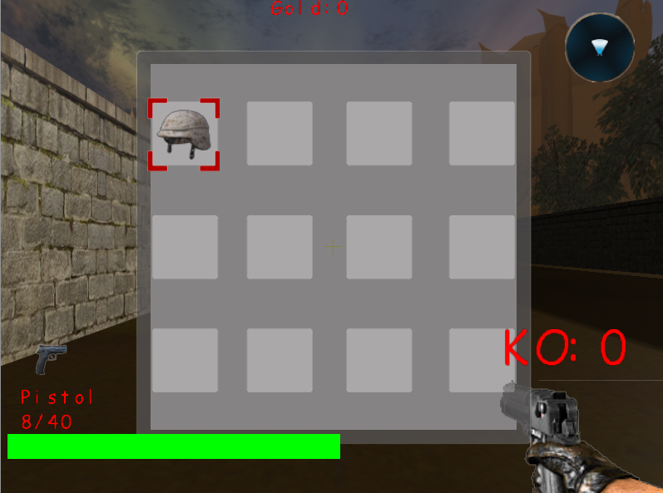

## Equipment

Increase attributes to power up player.

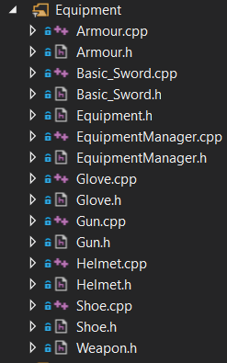

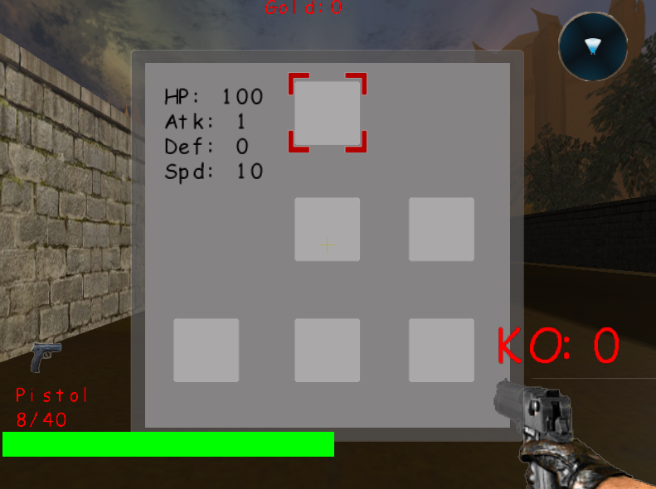

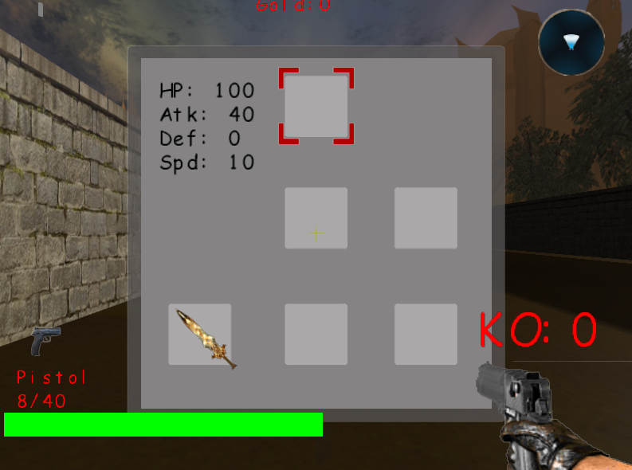

## Shop

### Purchase equipment

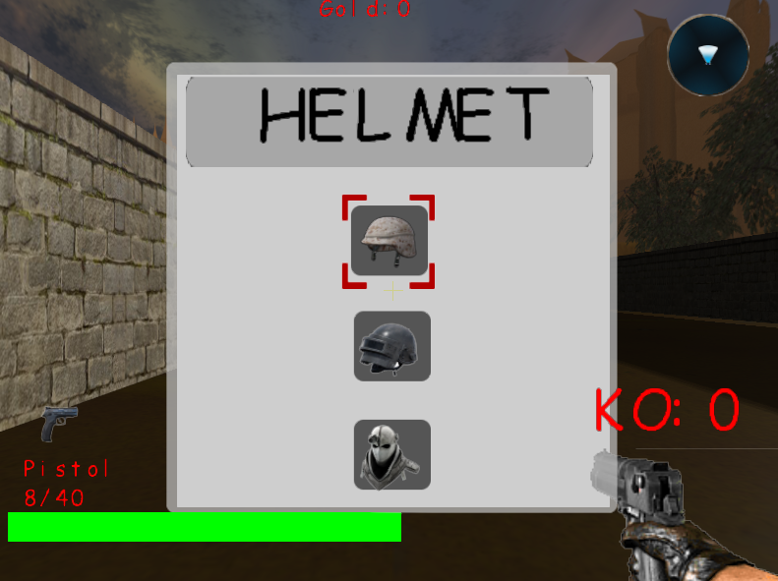

# 160853T / Kwong Yu Ming

## Attributes

Power-up the player and enemy status.

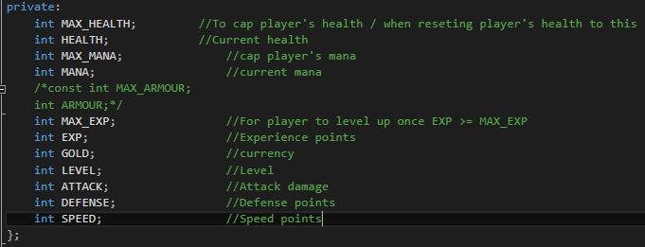

## Gamepad

Play the game using gamepad.

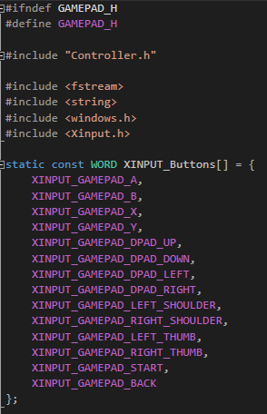

## Quest Manager

Creating quests for player to complete.

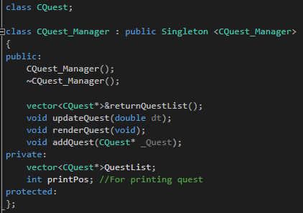

## Transformation of Objects

### Walking animation [Robot]

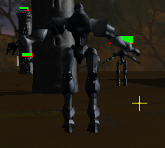

## Object and TGA

Skybox, Tower, Turret, Robot and environmental objects.

